Game N' Watch: Design Document
John Reese, Benjamin Roux, Andrew Storrow
11/5/07

Presentation Tier:

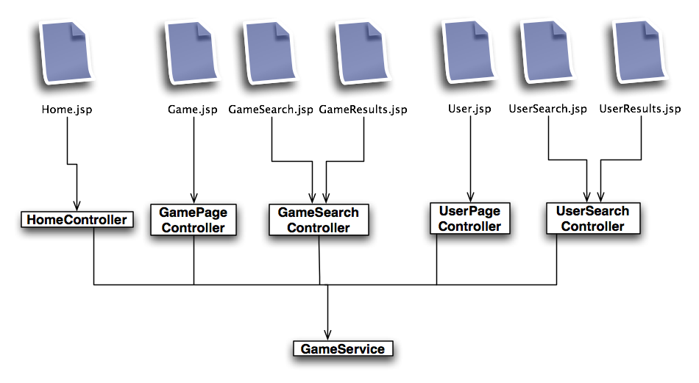

The presentation tier was made using Spring’s built-in MVC framework. There is a dispatcher servlet that interprets incoming html page requests and maps each of those html addresses to a controller class. The controller classes are POJO’s which either inherit from Spring’s Controller interface for basic functionality or SimpleFormController for form functionality. The controllers then call the appropriate methods in the appropriate service class, UserService (not shown) for user related functionality or GameService for game related requests, and populate a model object with the necessary information. This model object is then returned along with the address of the jsp page to display. This jsp page uses the returned model object to display dynamic information such as that coming from the database.

Application Tier:

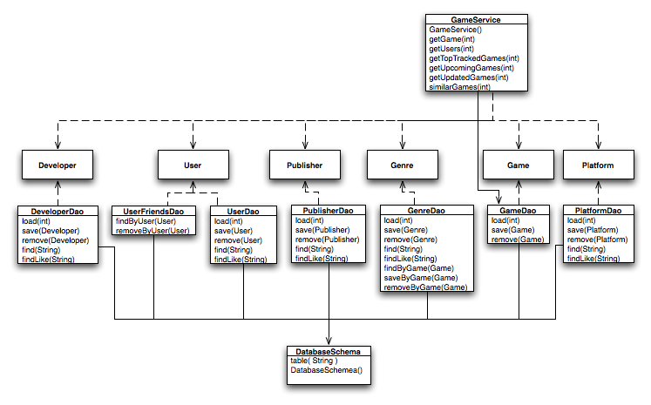

Since our application was fairly simple in terms of functionality the application tier was in turn simple as well. The bulk of it consists of POJO’s representing each of the major object types we have in our system. There is a corresponding DAO (data access object) for each of these classes which provides database functionality such as loading an object from the database or saving an object. This allows us to have all SQL code contained in the DAO classes meaning for the rest of the system we can code using the objects themselves and not have to worry about constructing queries. DatabaseSchema is responsible for maintaining the structure of the database tables so that if they disappear or change they will automatically be rebuilt.
The service classes provide a sort of façade to all of this containing functions used by the presentation tier to display the necessary data and perform the needed tasks. For the functionality we implemented there were two service classes, GameService and UserService (not shown). GameService provides features such as loading a given games information, or returning a list of the top tracked games, upcoming games, or recently updated games. UserService provides the ability to load a user’s information, get a list of users tracking a certain game and other useful things. In the fully featured system there would likely be other service classes such as a publisher service or developer service.

Database Model:

